ANA-050 Functional Specification
Simpsons Beverages: Schedule Number Generation V3.0

Document Properties
Authors | Eshan Fernando | Infor M3 Consultant

Approvers | Joe Walker | Solution Architect | Date: 24/10/2025
Approvers | Bevon Raj | Senior Consultant | Date: 24/10/2025

Change Control | Eshan Fernando | Creation | Date: 24/10/2025
Change Control | Eshan Fernando | Display next available schedule number in the sequence against the production line | 28/11/2025
Change Control | Eshan Fernando | Logic change to identify the latest schedule number used | 12/01/2026
Change Control | Eshan Fernando | Sequence number on the schedule number to be in multiples of 10, elaborate next schedule number calculation and displaying next schedule number, updates to assumptions | 14/01/2026
Change Control |  |  | Date

Contents
ANA-050 Functional Specification 1
Document Properties 1
Contents 1
Introduction 2
Functional Overview 2
Current process 2
Proposed process 2
Below is the sequence in which APIs are executed. 5
Assumptions & Limitations 10

Introduction
This ANA-050 Functional Specification provides a functional solution for the Schedule Number Generation V3.0 requested by Simpsons Beverages.
It is not intended to provide technical information. Any supporting technical information can be found in the accompanying ‘TAR-040 Technical Specification’ document, if provided.

The primary objective of this specification is to provide a functional overview of a solution to the proposed modification.

It does not consist of any training material that explains to a detailed level how the deliverables form the functional solution. It is expected that the reader of this document is to have a good understanding of any Infor M3 programs mentioned within this specification.

Functional Overview

Current process
Currently, Simpsons does not maintain separate planned and confirmed orders in their planning process. The practice is to calculate daily production requirements on a spreadsheet and translate it to a production plan. On the production plan, production orders are sequenced based on a range of factors. These factors include the inclusion of certain elements on the recipe (Such as gum), packaging needed, customer the order is intended for etc. Once the production sequence is finalized for the day, it is then followed by the employees on the production floor.

Below is a sample production plan followed by the packaging team.

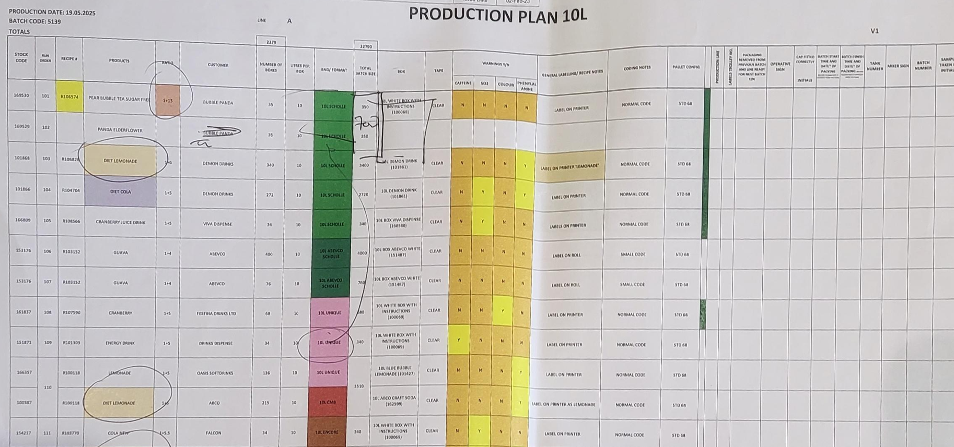
Figure 1: Current production plan.

Proposed process
Production planning and scheduling in Infor Cloudsuite happens during the planning stage. Material Requirements Planning (MRP) engine in Infor Cloudsuite works in such a way that it considers customer demand, sales forecast, existing orders, stock levels and suggests production proposals respecting lead time so that production planners could review and release proposals to the production floor as a confirmed plan. To achieve a confirmed plan, production planners are given visibility to information such as the packaging needed, customer the order it is intended for, inclusion of a gum item on the custom list view built for planning. Production planners will also consider factors such as material shortages and capacity requirements to sequence production proposals by assigning schedule numbers.

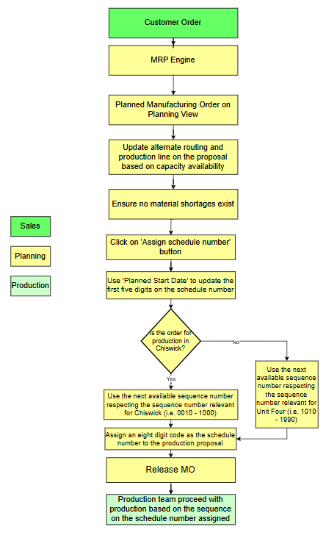
Figure 2: Proposed planning process.

There will also be a display on the planning view showing the next available schedule number based on the production line entered. The next available schedule number is calculated by adding ten to the latest schedule number on the list of proposals within the production line which has a start date today.
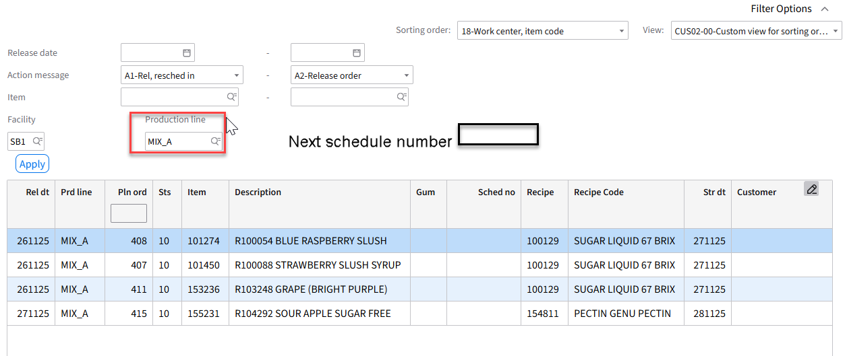
Figure 3: Sample planning view
When sequencing production proposals in Infor Cloudsuite, a system-generated sequence number is attached to each production proposal. However, as per standard behavior, this is an incremental number that automatically resets once it reaches a specific number (i.e. 999). Instead of using the standard schedule number proposed by Infor Cloudsuite, Simpsons Beverages wish to use a custom schedule number for each of their two production areas, namely Chiswick House and Unit Four. To facilitate this requirement a development is proposed which generates a schedule number respecting the following pattern.

 | First five digits on the schedule number | Final three digits on the schedule number | Sample
Chiswick House | Julian day code in YYNNN format based on the planned start date on the proposal | Sequence number that is representative of Chiswick House | 252960010
Unit Four | Julian day code in YYNNN format based on the planned start date on the proposal | Sequence number that is representative of Unit Four | 252961010
Table 1: Proposed schedule numbering logic for Chiswick House and Unit Four.
Below is the formation logic for the schedule number.

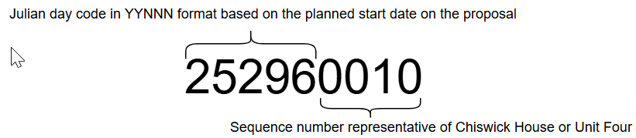

‘Assign Schedule Number’ button is implemented on the custom list view built for planning. When a production planner clicks on it, a schedule number is attached to a production proposal. In the event multiple production proposals are selected and ‘Assign Schedule Number’ button clicked, all production proposals selected will be assigned the schedule number attached to the first production proposal in the selection. Julian day code on the schedule number is calculated based on the start date on the first production proposal in the selection. Based on the Julian day code and the production line, Infor Cloudsuite then performs a check to identify the next available sequence number and assigns it to (the) production proposal(s).

The latest schedule number applicable for Chiswick House and Unit Four are maintained in CUGEX3 table. During go-live 250010010 is added as the schedule number for Chiswick House while 250011010 is added as the schedule number for Unit Four. From thereon, each time a schedule number is updated against a production proposal this information is updated.

Below is the sequence in which APIs are executed.
When production proposal(s) is(are) selected and ‘Assign Schedule Number’ button clicked on the custom list for planning, below sequence of APIs needs to be executed. In the event multiple production proposals are selected and ‘Assign Schedule Number’ button clicked they will all be assigned the same schedule number attached to the first production proposal in the selection.

Step 01: Extract the Julian Day code applicable to the planned start date on the production proposal.
  - API: CRS900MI
  - Transaction: GetSysCalDate
Description | Field | Test Value | Extraction Method
Date YYYYMMDD | YMD8 | 20251024 | Start date against the production proposal selected in the planning view. If multiple production proposals are selected, pick the start date against the first production proposal in the selection.
Table 2: Inputs to obtain the Julian Day code relating to the planned start date.
Description | Field
Day Number YYYYNNN | YDNO
Table 3: Julian Day code extracted from CRS900MI: GetSysCalDate.
Julian Day code extracted from Table 3 needs to be converted to YYNNN format by omitting the first two characters on the output.

Step 02: Retrieving the latest schedule number.

Step 02.01. Retrieve production lines belonging to Chiswick House.
- API: CRS881MI
- Transaction: LstTranslation
Description | Field | Test Value | Extraction Method
Record Type | TRQF | 1 | Maintain as a configurable field in the parameter file
Message Standard | MSTD | CHI | Maintain as a configurable field in the parameter file
Message version | MVRS | 1 | Maintain as a configurable field in the parameter file
Business message | BMSG | Chiswick Production | Maintain as a configurable field in the parameter file
Inbound or outbound message | IBOB | I | Maintain as a configurable field in the parameter file
Parent element(s) | ELMP | CHI | Maintain as a configurable field in the parameter file
Data element | ELMD | CHI | Maintain as a configurable field in the parameter file
Table 4: Inputs to retrieve production lines belonging to Chiswick House
Based on inputs to Table 4, below outputs are obtained.

Description | Field | Test Value
External partner address | EXTP | 10L_A
Movex data | MVXD | 10L_A
Message data | MBMD | Pack
Table 5: Chiswick House production lines
If production line on the production proposal selected on the planning view matches with one of the Movex data records in Table 5, proceed to Step 02.02. Else proceed to Step 02.03.

Step 02.02. Retrieve last used schedule number for Chiswick House
- API: CUSEXTMI
- Transaction: GetAlphaKPI
Description | Field | Test Value | Extraction Method
KPI ID | KPID | CHI | Maintain as a configurable field if needs amending later
Primary key 1 | PK01 | CHI | Maintain as a configurable field if needs amending later
Table 6: Inputs to extract last used schedule number for Chiswick House
Based on inputs to Table 6, below outputs are obtained.

Description | Field | Test Value
Alpha Field 30 positions | AL30 | 250010010
Table 7: Output from CUSEXTMI: GetAlphaKPI

Step 02.03. Retrieve last used schedule number for Unit Four
- API: CUSEXTMI
- Transaction: GetAlphaKPI
Description | Field | Test Value | Extraction Method
KPI ID | KPID | U4 | Maintain as a configurable field if needs amending later
Primary key 1 | PK01 | U4 | Maintain as a configurable field if needs amending later
Table 8: Inputs to extract last used schedule number for Unit Four
Based on inputs to Table 8, below outputs are obtained.

Description | Field | Test Value
Alpha Field 30 positions | AL30 | 250011010
Table 9: Output from CUSEXTMI: GetAlphaKPI

Step 03: Calculate the schedule number

Step 03.01. Schedule Number for Chiswick House
Next available schedule number is calculated based on the output from Table 7, planned start date (ROSTDT) on the first proposal in the selection. If the Julian day code (remove first 2 digits) 20 26032 compare this with CUGEX Value 250010010 compare with first 5 digits 25001, next schedule number will be calculated by adding 0010 (250010010 + 10 = 250010020)to the sequence number, else schedule number will be calculated based on the julian day code on the start date on the first proposal in the selection with the sequence number being 0010.eg (start date 260320010) remove first 2 digits of Julian code

Step 03.02. Schedule Number for Unit Four
Next available schedule number is calculated based on the output from Table 7, planned start date (ROSTDT) on the first proposal in the selection. If the Julian day code (remove first 2 digits) 20 26032 compare this with CUGEX Value 250011010 compare with first 5 digits 25001, next schedule number will be calculated by adding 0010 (250011010 + 0010 = 250011020)to the sequence number, else schedule number will be calculated based on the julian day code on the start date on the first proposal in the selection with the sequence number being 1010.eg (start date 260321010) remove first 2 digits of Julian code
.

An example as follows.

Values against the production proposal selected on the planning view | Sample value against the production proposal selected on the planning view | Digits on the schedule number output field is mapped to | Mapping to schedule number | Sample
ROSTDT | 20251024 | 1-5 | Convert to Julian Day code in YYNNN format | 252970010
ROWCLN | MIX_A | 6-9 | Next available number in the sequence | 252970010
Table 10: Calculation of schedule number.

Step 04: Assigning schedule number(s) to the production proposal(s).
  - API: PMS170MI
  - Transaction: Updat
Description | Field | Test Value | Extraction Method
Planned order | PLPN | 834 | Use the planned order number based on the production proposal(s) selected on the custom list for planning. If multiple production proposals are selected, feed the proposal number one after the other in a loop
Schedule number | SCHN | 5296001 | Schedule number calculated in Step 03.
Table 11: Inputs to assign schedule number(s) to the selected planned order(s).

Step 05: Updating the last used schedule number

Step 05.01: Updating the last used schedule number against Chiswick House
- API: CUSEXTMI
- Transaction: ChgAlphaKPI
Description | Field | Test Value | Extraction Method
KPI ID | KPID | CHI | Maintain as a configurable field if needs amending later
Primary key 1 | PK01 | CHI | Maintain as a configurable field if needs amending later
Alpha field 30 positions | AL30 | 250120010 | Schedule number calculated in Step 03.01
Table 12: Updating the last used schedule number against Chiswick House

Step 05.02: Updating the last used schedule number against Unit Four
- API: CUSEXTMI
- Transaction: ChgAlphaKPI
Description | Field | Test Value | Extraction Method
KPI ID | KPID | U4 | Maintain as a configurable field if needs amending later
Primary key 1 | PK01 | U4 | Maintain as a configurable field if needs amending later
Alpha field 30 positions | AL30 | 250121010 | Schedule number calculated in Step 03.02
Table 13: Updating the last used schedule number against Unit Four

Step 06: Reset last used schedule number against Chiswick House and Unit Four at the end of the century/ beginning of a new century.
This needs to scheduling to run after working hours on December 31st at the end of the century (i.e. 2099) or before working hours on January 1st beginning of the century (i.e. 2100).

Step 06.01: Change schedule number against Chiswick House
- API: CUSEXTMI
- Transaction: ChgAlphaKPI
Description | Field | Test Value | Extraction Method
KPI ID | KPID | CHI | Maintain as a configurable field if needs amending later
Primary key 1 | PK01 | CHI | Maintain as a configurable field if needs amending later
Alpha field 30 positions | AL30 | 000010010 | Maintain as a configurable field if needs amending later
Table 14: Inputs to change the latest schedule number against Chiswick House

Step 06.02: Change schedule number against Unit Four
- API: CUSEXTMI
- Transaction: ChgAlphaKPI
Description | Field | Test Value | Extraction Method
KPI ID | KPID | U4 | Maintain as a configurable field if needs amending later
Primary key 1 | PK01 | U4 | Maintain as a configurable field if needs amending later
Alpha field 30 positions | AL30 | 000011010 | Maintain as a configurable field if needs amending later
Table 15: Inputs to change the latest schedule number against Unit Four
Step 07: Display the next available schedule number on the custom view for planning.

Step 07.01: Production proposal selected in the planning view belongs to a production line in Chiswick House
- API: CUSEXTMI
- Transaction: GetAlphaKPI
Description | Field | Test Value | Extraction Method
KPI ID | KPID | CHI | Maintain as a configurable field if needs amending later
Primary key 1 | PK01 | CHI | Maintain as a configurable field if needs amending later
Table 16: Inputs to display the latest schedule number against Chiswick House
Based on inputs to Table 16 , below outputs are obtained.

Description | Field | Test Value
Alpha Field 30 positions | AL30 | 250010010
Table 17: Output from CUSEXTMI: GetAlphaKPI
Next available schedule number is calculated based on the output from Table 17, planned start date (ROSTDT) on the first proposal in the selection. If the Julian day code (First five digits) on the last used schedule number in Table 17 matches the planned start date (ROSTDT) on the first proposal in the selection, next schedule number will be calculated by adding 10 to the sequence number, else schedule number will be calculated based on the planned start date on the first proposal in the selection with the sequence number being 0010.

Step 07.02: Production proposal selected in the planning view belongs to a production line in Unit Four
- API: CUSEXTMI
- Transaction: GetAlphaKPI
Description | Field | Test Value | Extraction Method
KPI ID | KPID | U4 | Maintain as a configurable field if needs amending later
Primary key 1 | PK01 | U4 | Maintain as a configurable field if needs amending later
Table 18: Inputs to display the latest schedule number against Unit Four
Based on inputs to Table 18, below outputs are obtained.

Description | Field | Test Value
Alpha Field 30 positions | AL30 | 250011010
Table 19: Output from CUSEXTMI: GetAlphaKPI
Next available schedule number is calculated based on the output from Table 19, planned start date (ROSTDT) on the first proposal in the selection. If the Julian day code (First five digits) on the last used schedule number in Table 19 matches the planned start date (ROSTDT) on the first proposal in the selection, next schedule number will be calculated by adding 10 to the sequence number, else schedule number will be calculated based on the planned start date on the first proposal in the selection with the sequence number being 1010.

Assumptions & Limitations
- Julian day code will be in YYNNN format.
- Schedule numbers in Infor M3 CloudSuite will be reset after working hours at the end of a century or before working hours at the beginning of a century.
- Julian Day code on the schedule number is determined based on the planned start date on the production proposal.
- Sequence number on the schedule number is determined based on the production line on the production proposal and the latest sequence number on schedule numbers already in Infor Cloudsuite.
- Production proposals with the same release or start date will be scheduled together. i.e. Production proposals with a start date of today assigned a schedule number before assigning schedule numbers to production proposals with a start date of tomorrow.
- If multiple production proposals are selected to ‘Assign Schedule Number’ they will all pick the schedule number attached to the first production proposal in the selection.
- If a mistake is made when assigning schedule numbers to a production proposal, it needs to be handled outside the scope of this development, where the schedule number needs to be deleted and added using the related options on the custom list for planning.
- The default production line for all manufactured items needs to be maintained against Item/ Facility (MMS003) record.
- Production line and the alternate routing on a production proposal needs to be correct prior to clicking on ‘Assign Schedule Number’ button.
- Schedule number assigned by the development will always be additions of 10 to account for any flexibility planners would need.
- ‘Joint scheduling’ related option in PMS170 will be disabled once the development is active.
- ‘Assign Schedule Number’ button will be made available only on the custom list view for planning.
- At least one planned order needs to be selected prior to clicking on ‘Assign Schedule Number’ button.
- At least one planned order needs to be selected prior to the planning view displaying ‘Next schedule number’.
- Maximum production runs per day in Chiswick House or Unit Four will not exceed one hundred.

